

SUSTAINABLE PROCUREMENT POLICY
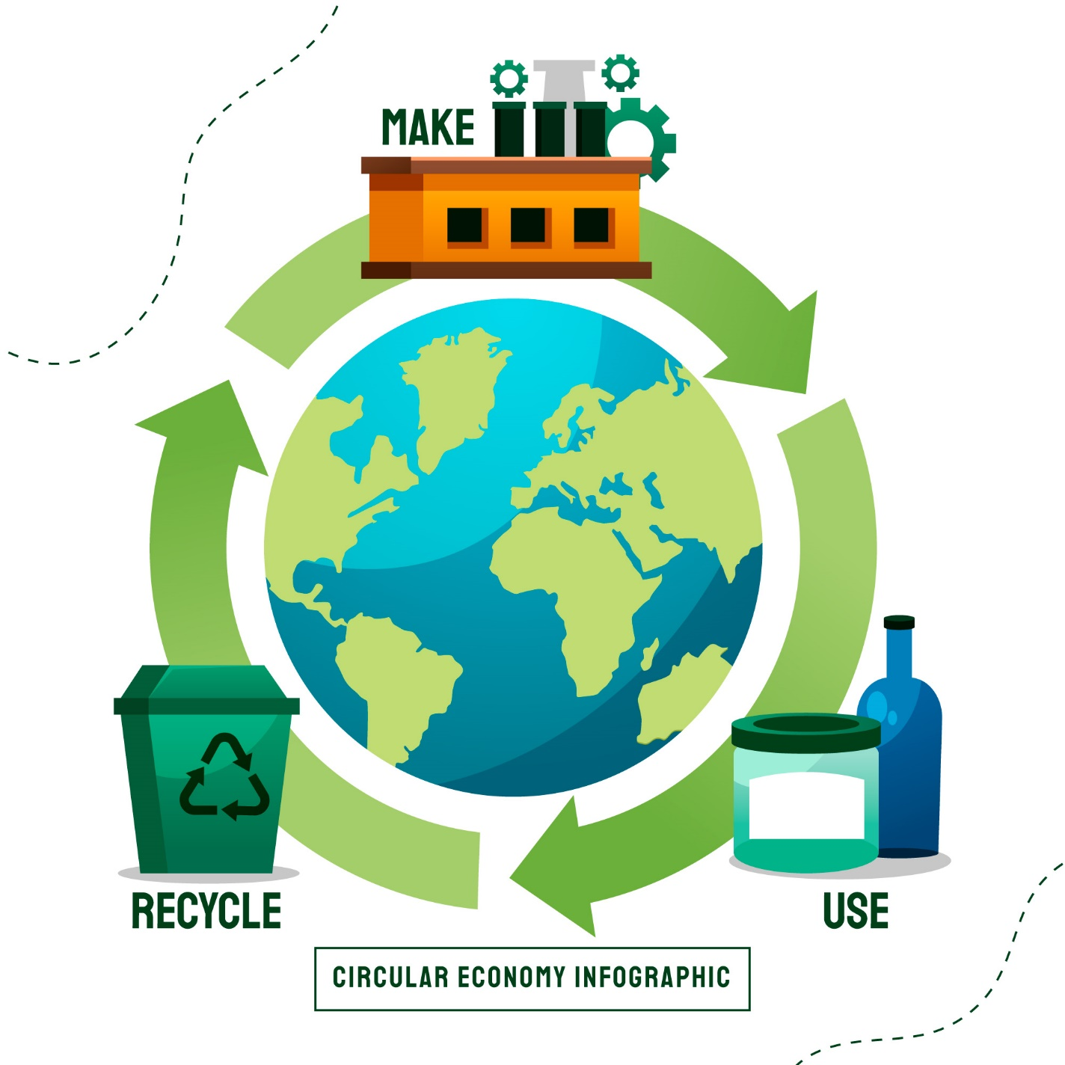
Effective Date: 01-01-2024

Contents

1. INTRODUCTION 3
2. SCOPE 3
3. POLICY STATEMENT 3
4. KEY FOCUS AREAS 3
5. QUALITATIVE TARGETS 5
6. QUANTITATIVE TARGETS 7
7. CONTINUOUS IMPROVEMENT 9
8. REPORTING 9
9. REVIEW MECHANISM 9

INTRODUCTION
At Graham Packaging, our sustainable procurement policy reflects our deep commitment to environmental responsibility, social equity, and economic prosperity. We understand that our actions today impact the world tomorrow, and thus, we operate with a triple bottom line approach, valuing people, planet, and profit equally. Our plastic bottle manufacturing operations are guided by this ethos, as we strive to build a sustainable future for generations to come. By integrating sustainable practices into our procurement processes, we not only minimize our environmental footprint but also contribute to the well-being of communities and foster innovation within our industry.

SCOPE
This Policy applies exclusively to the operations of Graham Packaging Company, encompassing all employees, contractors, suppliers, and stakeholders directly associated with our facilities.
Sr. No. | Name of Site | Address
1 | Graham Packaging Company | 700 Indian Springs Drive  Suite 100  Lancaster, PA 17601

POLICY STATEMENT
Graham Packaging is committed to sustainable procurement practices. We prioritize ethical sourcing, environmental responsibility, and community engagement in our supply chain. Through continuous improvement and stakeholder collaboration, we aim to build a sustainable future while delivering value to our customers.

KEY FOCUS AREAS
- Supplier Environmental Issues:
- Material Sourcing: Ensure suppliers source materials from sustainable and eco-friendly sources, such as recycled plastics or bio-based materials, to reduce environmental impact.
- Waste Management: Partner with suppliers to develop effective waste management strategies, including recycling and reuse initiatives, to minimize waste generation and promote a circular economy.
- Water Conservation: Encourage suppliers to adopt water-saving technologies and practices to minimize water usage and reduce the strain on local water resources.
- Emissions Reduction: Implement measures to monitor and reduce greenhouse gas emissions from manufacturing processes, transportation, and other operations to mitigate climate change impacts.

- Supplier Social Issues:
- Labor Standards: Ensure suppliers adhere to fair labour standards and provide safe working conditions for employees, including fair wages, reasonable working hours, and access to healthcare and other benefits.
- Diversity and Inclusion: Support supplier diversity initiatives by promoting the inclusion of minority-owned and women-owned businesses in the supply chain, fostering a more diverse and inclusive industry.
- Community Engagement: Encourage suppliers to engage with local communities and support social development projects, such as education and healthcare initiatives, to contribute positively to society.
- Ethical Business Practices: Require suppliers to uphold ethical business practices, including transparency, integrity, and compliance with relevant laws and regulations, to ensure responsible and ethical conduct throughout the supply chain.

QUALITATIVE TARGETS
- Supplier Environmental Issues:
- Material Sourcing: Prioritize suppliers who source materials sustainably, such as recycled plastics or bio-based materials. For example, collaborating with suppliers who offer certified recycled plastics derived from post-consumer waste.
- Waste Management: Partner with suppliers to minimize waste generation through recycling and reuse initiatives. For instance, establishing a closed-loop system with suppliers for the collection and recycling of plastic waste generated during production.
- Water Conservation: Encourage water-saving technologies to reduce water usage in production processes. This could involve implementing water recycling systems or investing in water-efficient equipment.
- Emissions Reduction: Implement measures to monitor and reduce greenhouse gas emissions across operations. For example, transitioning to cleaner energy sources or optimizing transportation routes to minimize carbon emissions.

- Supplier Social Issues:
- Labor Standards: Ensure suppliers provide safe working conditions and fair wages for employees. Conduct regular audits to verify compliance with labor regulations and address any identified issues promptly.
- Diversity and Inclusion: Promote diversity by including minority-owned and women-owned businesses in the supply chain. Actively seek out diverse suppliers and provide them with opportunities to participate in procurement processes.
- Community Engagement: Encourage suppliers to support local community projects and initiatives. Partner with suppliers to sponsor community events or volunteer programs aimed at improving the well-being of local communities.
- Ethical Business Practices: Require suppliers to uphold ethical standards and comply with relevant regulations. Incorporate ethical conduct clauses into supplier contracts and conduct regular assessments of supplier compliance.

QUANTITATIVE TARGETS
- Supplier Environmental Issues:
- Material Sourcing:
- Increase the percentage of materials sourced from sustainable and eco-friendly sources to 50% by 2025, compared to 2018 levels.
- Waste Management:
- Reduce waste generation by 30% compared to 2018 levels through improved recycling and reuse initiatives by 2025.
- Ensure that 90% of suppliers have implemented effective waste management strategies by 2025 compared to 2018.
- Water Conservation:
- Decrease water usage by 20% per unit of production by 2025 compared to 2018 levels.
- Implement water-saving technologies in 100% of manufacturing facilities by 2025 compared to 2018.
- Emissions Reduction:
- Reduce greenhouse gas emissions by 40% across manufacturing processes and transportation by 2025 compared to 2018 levels.

- Supplier Social Issues:
- Labor Standards:
- Ensure that 100% of suppliers adhere to fair labour standards and provide safe working conditions by 2025 compared to 2018.
- Conduct regular audits with 95% compliance with labour standards across the supply chain by 2025 compared to 2018.
- Diversity and Inclusion:
- Increase the representation of minority-owned and women-owned businesses in the supply chain by 25% by 2025, compared to 2018 levels.
- Community Engagement:
- Engage in at least three community development projects annually through partnerships with suppliers by 2025 compared to 2018.
- Allocate 1% of annual procurement budget towards community engagement initiatives by 2025 compared to 2018.
- Ethical Business Practices:
- Ensure 100% of suppliers uphold ethical business practices, including transparency and integrity, by 2025 compared to 2018.
- Implement a whistleblower mechanism to report unethical practices, achieving a 95% resolution rate by 2025 compared to 2018.

CONTINUOUS IMPROVEMENT
- Continuous improvement is integral to our sustainable procurement strategy at Graham Packaging.
- We focus on optimizing processes, monitoring performance, and soliciting feedback from stakeholders to drive positive change.
- Through ongoing training, innovation, and collaboration, we strive to enhance sustainability across our supply chain.
- By benchmarking against industry standards, managing risks, and fostering a culture of innovation, we ensure that our sustainability efforts evolve and improve over time, leading to a more sustainable future for all.

REPORTING
- We have established a robust reporting mechanism to monitor our progress and identify areas for improvement.
- Regularly collect data on supplier performance related to environmental and social practices
- Maintain transparency in reporting and engage stakeholders in the process.

REVIEW MECHANISM
- Annually assess policy effectiveness, reviewing achievements, challenges, and opportunities to ensure alignment with sustainability goals and industry best practices. Adjust strategies as needed to drive continuous improvement.
- Based on the findings of this yearly review, we propose necessary adjustments or enhancements to uphold our commitment to Sustainable Procurement.

